**HOTEL BOOKINGS MANAGEMENT SYSTEM**

**ABSTRACT**

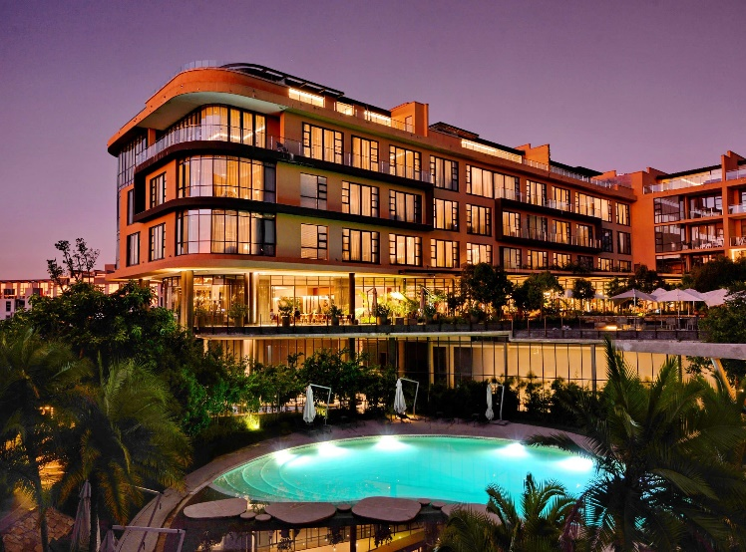This project designs and implements a hotel booking system using SQL. The system stores and manages data about customer bookings, customers & employees. It also generates reports and queries for decision making. The project follows six phases: design, implementation, user interface development, testing, report generation and documentation. The project uses a relational database model and the waterfall methodology. The project shows how SQL can create and manipulate databases effectively. The project also shows how a booking management system can improve a hotel’s efficiency and effectiveness.

* **AIM OF PROJECT**

The aim of this project is to design and implement a hotel bookings management system using SQL. The system stores and manages data about customer bookings, customers & employees. The system will also provide various reports and queries to help the employees and managers perform their tasks efficiently and effectively.

* **INTRODUCTION**

Hotel Management System is a software system where the management of entire hotel is computerized. The hotel management system is designed using a secured database. In this project the details are maintained like customer details, reservation details, booking details and billing details. The reservation process of reserving rooms for the customers, cancelling the reserved rooms, booking the rooms, the food order management, billing process, etc all are computerized and the management is done without difficulty. hey also offer services such as car maintenance, repair, insurance and financing. The system also provides various reports and queries to help them perform their tasks efficiently and effectively. The aim of this project is to design and implement a hotel’s booking management system using SQL. The objectives of this project are to create a relational database schema, implement the database, create various stored procedures, functions, triggers and views, develop a user interface, test the functionality and performance of the system, generate various reports and queries, and document the system design, implementation and testing process. The scope of this project is limited to the hotel’s booking management system only and does not include other aspects such as marketing, customer relationship management or online sales.

* **OBJECTIVE OF PROJECT**
* To design a relational database schema for the hotel’s booking management system using SQL.
* To generate various reports and queries to support the decision making of the hotel’s staff and managers.
* To document the system design, implementation and testing process.

**ER DIAGRAM**

|  |  |  |
| --- | --- | --- |
| Staff Table | | |
| PK | Staff_Id | Int |
|  | S_Firstname | Varchar (100) |
|  | S_Lastname | Varchar (100) |
|  | S_Phone_no | Varchar (10) |
|  | Designation | Varchar (255) |
|  | S_salary | Int |

|  |  |  |
| --- | --- | --- |
| Customer Table | | |
| PK | Cust_Id | Int |
|  | First_name | Varchar (100) |
|  | Last_name | Varchar (100) |
|  | City | Varchar (50) |
|  | Phone_no | Varchar (10) |
|  | Email | Varchar (100) |
|  | DOB | Date |

**Many to one**

|  |  |  |
| --- | --- | --- |
| Bookings Table | | |
| PK | Booking_Id | Int |
| FK | Staff_id | Int |
| FK | Cust_id | Int |
|  | No_of_people | Int |
|  | Room_no | Varchar (50) |
|  | Days | int |
|  | Checkin_Date | Date |
|  | Checkin_Time | Time |
|  | Checkout_Date | Date |
|  | Checkout_Time | Time |
|  | Booking_Mode | Varchar (50) |
|  | Mode_of_payment | Varchar (100) |
|  | Advance_payment | Int |
|  | Remaining_Payment | Int |

**STRUCTURE OF TABLE’S**

* CUSTOMERS

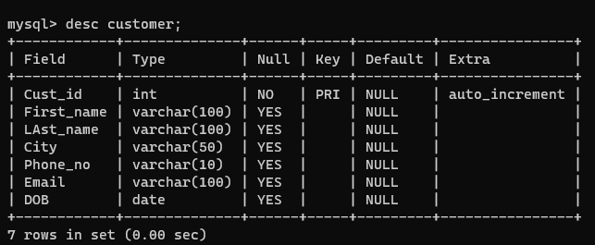

* STAFF

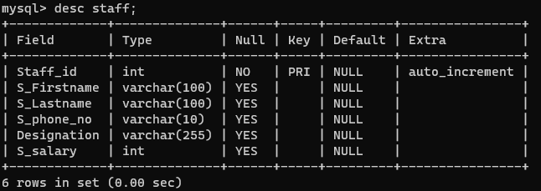

* BOOKINGS

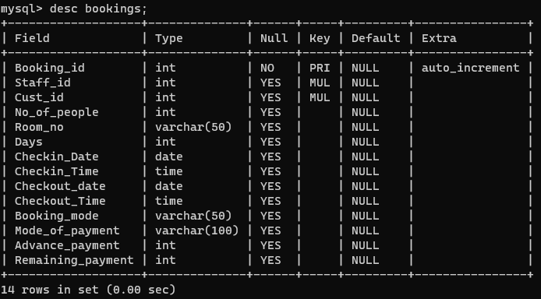

**CONTENT OF TABLE’S**

* CUSTOMERS

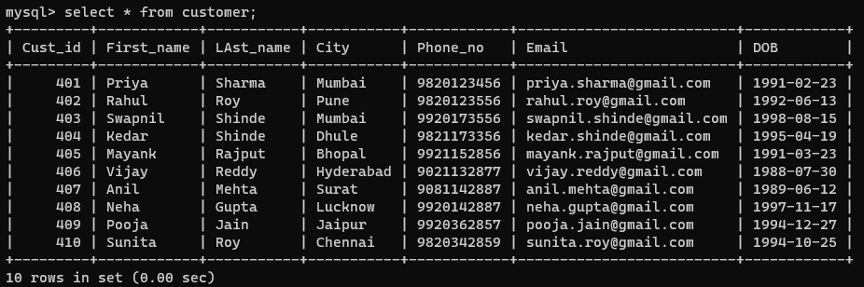

* STAFF

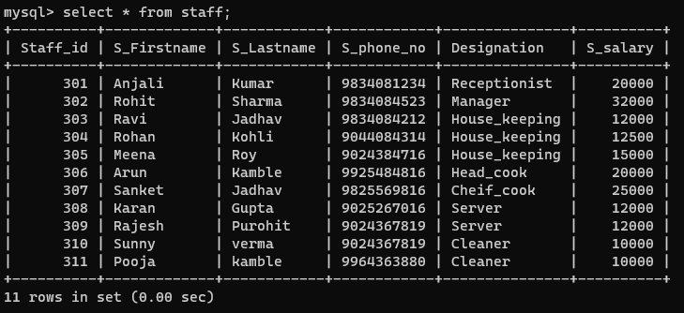

* BOOKINGS

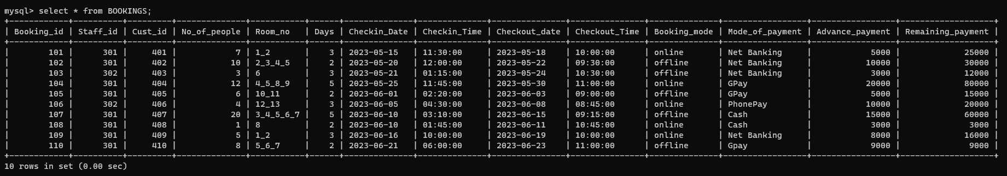

**OPERATOR’S**

* **ARITHMETIC**

**Write a query to find out the Total payment from the bookings table.**

**Query:**

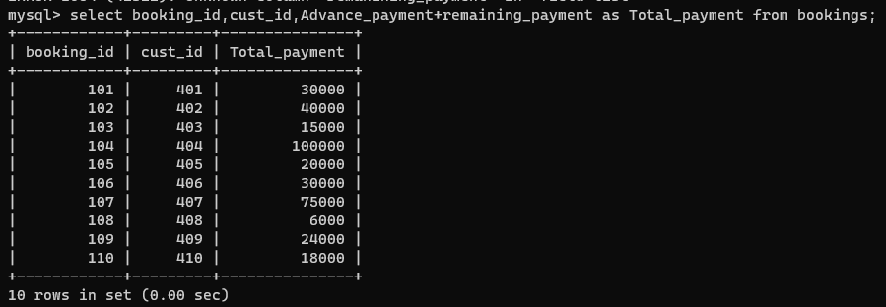

**Write a query for the bookings table for a special discount of 2000.**

**Query:**

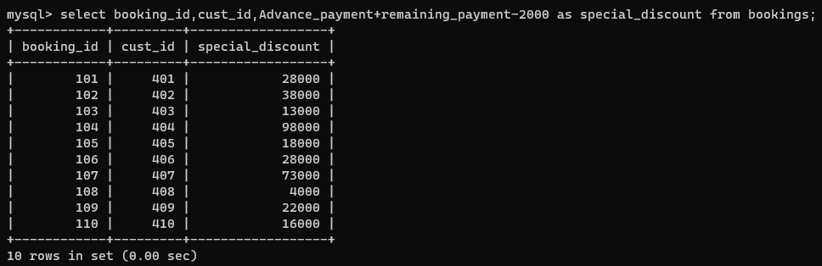

**Write a query to find out the annual salary of the staff with their names.**

**Query:**

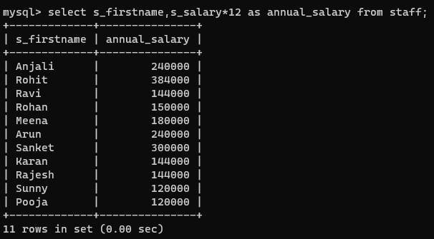

**Write a query to find out the per day salary of the staff with their names.**

**Query:**

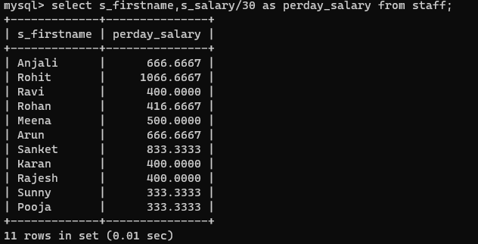

* **COMPARISON**

**Write a query to show the records of the staff having salary more than 12000, salary less than 15000 & salary greater than equal to 20000.**

**Query:**

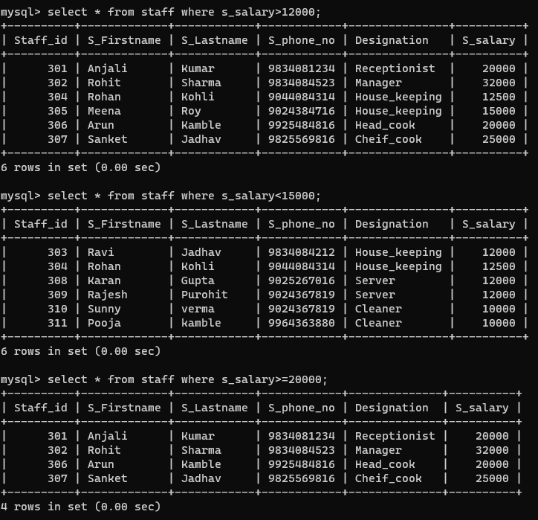

* **LOGICAL**

**Write a query to show the records of the staff having designation a ‘house_keeping’ & having salary more than 12000.**

**Query:**

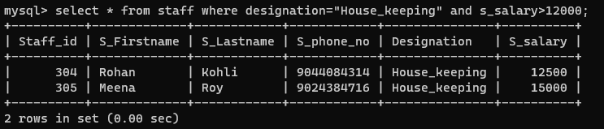

**Write a query to show the records of the staff having designation not equal to ‘cleaner’ & salary more than equal to 10000.**

**Query:**

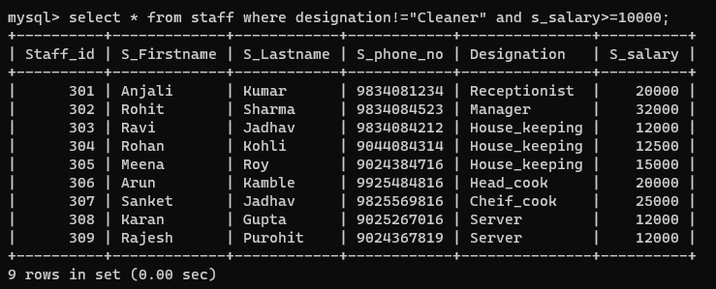

* **RANGE, LIKE, LIST**

**Write a query to show the salary range between 15000 – 45000.**

**Query:**

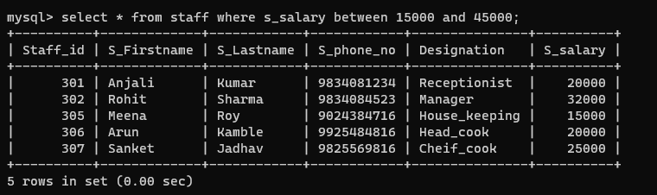

**Write a query to show the records of the customer having cust_id as 401,404,405,406,408& 402.**

**Query:**

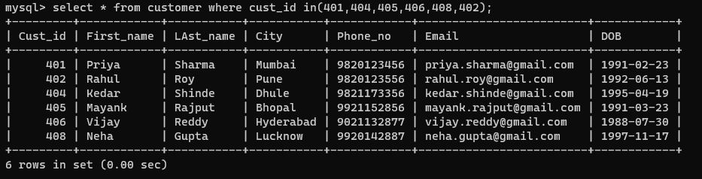

**Write a query to show the records having last name starting from ‘s’ from customer table.**

**Query:**

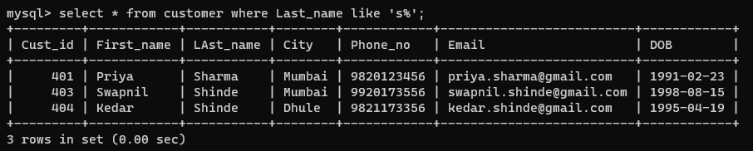

**Write a query to show the records having First name ending with ‘a’ from customer table.**

**Query:**

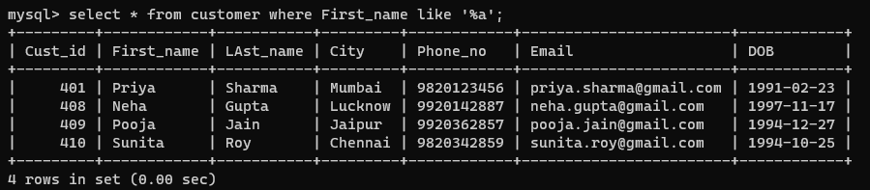

**Write a query to show the records of the customers having birthyear 1994.**

**Query:**

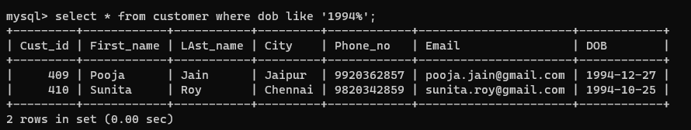

**Write a query to show the records of the staff having ‘98’ in their phone_no.**

**Query:**

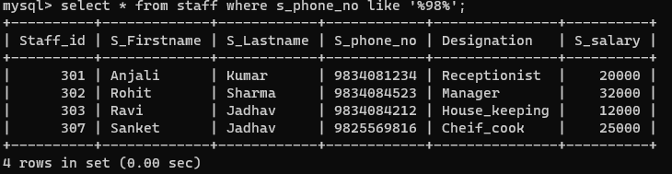

**Write a query to show the records of customers having ‘a, k’ in their First_name.**

**Query:**

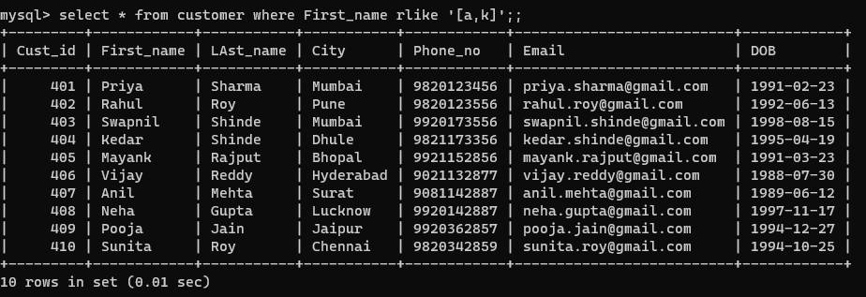

**AGGREGATE FUNCTION’S**

* MIN

**Write a query to show the minimum salary from the staff table.**

**Query:**

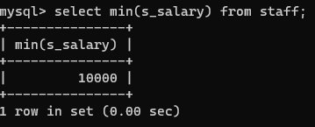

* MAX

**Write a query to show the maximum salary from the staff table.**

**Query:**

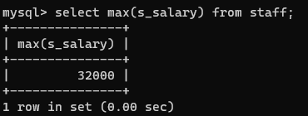

* SUM

**Write a query to show the sum of ‘advance payment and remaining payment’ from bookings table.**

**Query:**

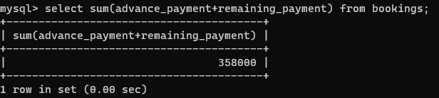

* AVG

**Write a query to show the staff having salary more than average salary with their designation.**

**Query:**

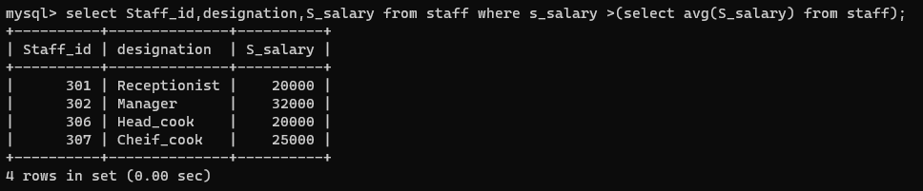

* COUNT

**Write a query to show the number of bookings.**

**Query:**

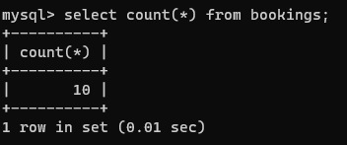

**CLAUSE’S**

* **WHERE CLAUSE**

**Write a query to show the cust_id of the customers which are from Mumbai.**

**Query:**

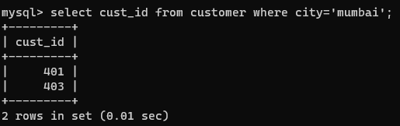

* **GROUP BY CLAUSE**

**Write a query to show the designation as manager with salary.**

**Query:**

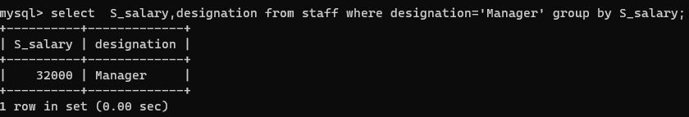

* **HAVING CLAUSE**

**Write a query to find the minimum salary of staff, below 15000 with respect to designation.**

**Query:**

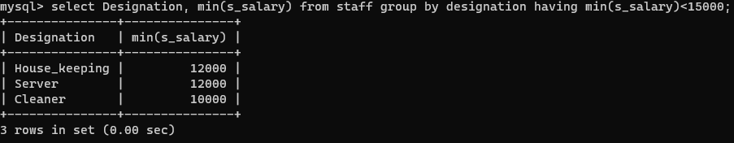

* **ORDER BY CLAUSE**

**Write a query to show records of customers in ascending order with respect to DOB.**

**Query:**

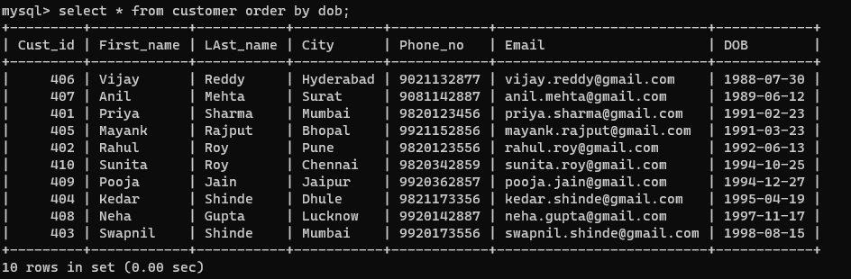

**Write a query to show records of customers in ascending order with respect to City.**

**Query:**

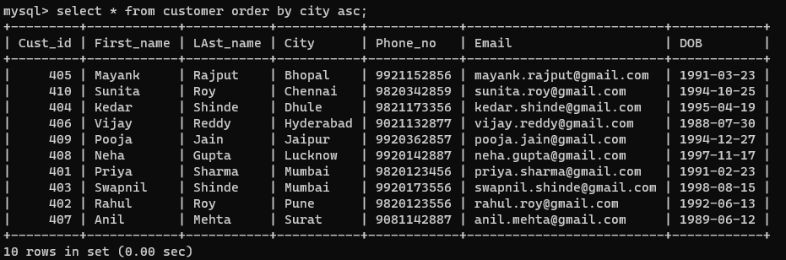

* **LIMIT CLAUSE**

**Write a query to show the records of first 5 customers and write a query to show the records of 6th and 7th customers.**

**Query:**

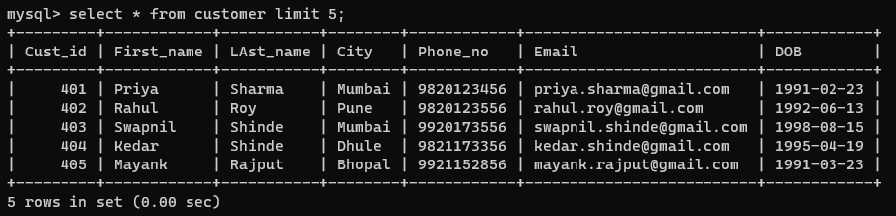

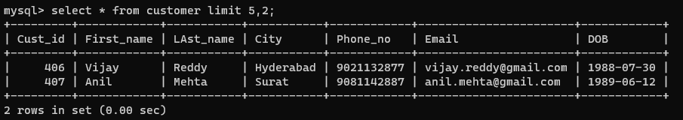

**JOIN’S**

**INNER JOIN**

**Write a query to inner join the bookings table and staff table with respect to booking id, customer id, days and staff records.**

**Query:**

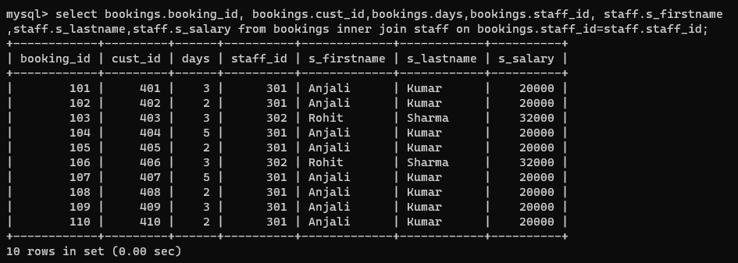

**LEFT JOIN**

**Write a query to left join bookings table on customer table.**

**Query:** 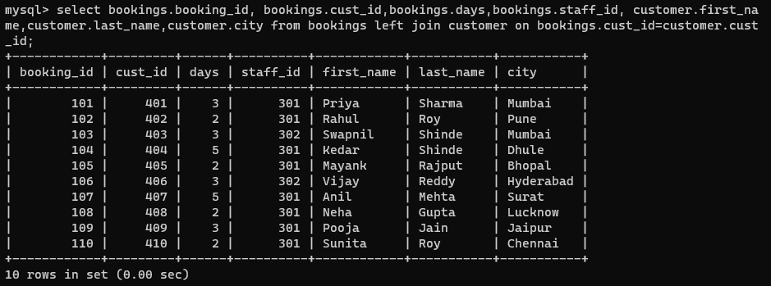

**RIGHT JOIN**

**Write a query to right join booking id, customer id from bookings table on customer table with first name, last name & their city.**

**Query:**

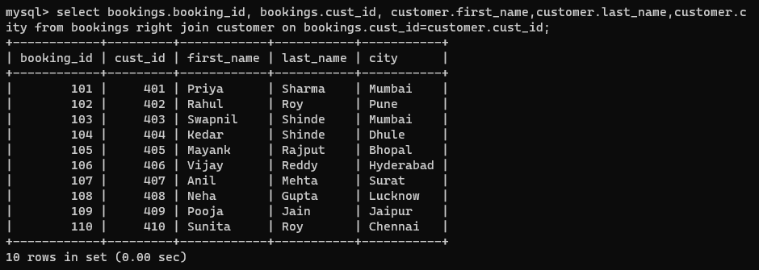

**CROSS JOIN**

**Write a query to cross join bookings table on staff table.**

**Query:**

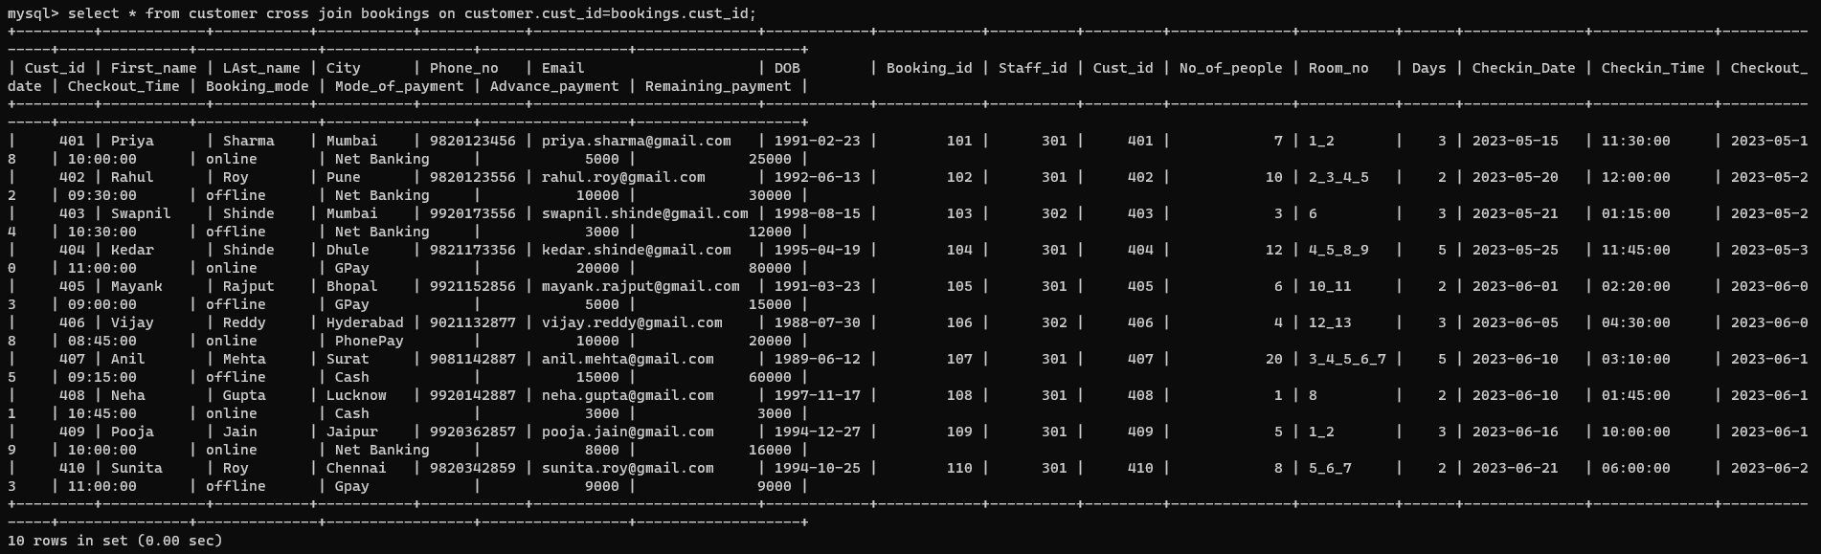

**SUB-QUERIES**

**Write a query to show the records of staff having salary more than average salary.**

**Query:**

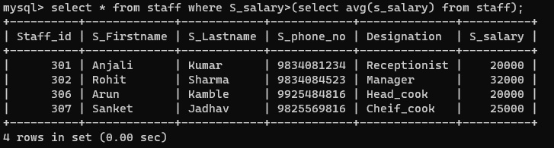

**Write a query to show the records of staff working in same designation as staff_id=303.**

**Query:**

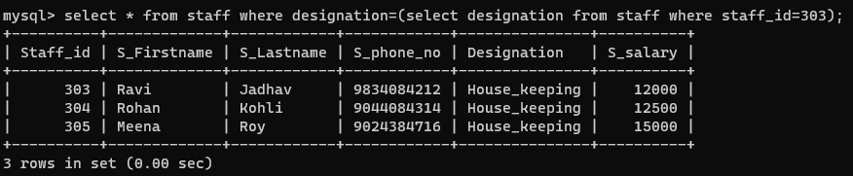

**Write a query to show the records of staff having the 3rd highest salary.**

**Query:**

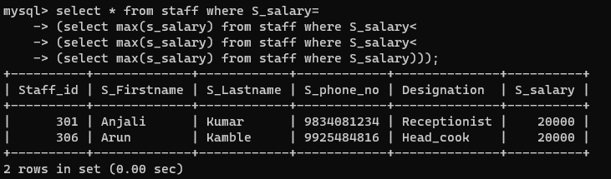

**OTHER FUNCTION’S AND STATMENT’S**

**Write a query to show only the first name of the customers.**

**Query:**

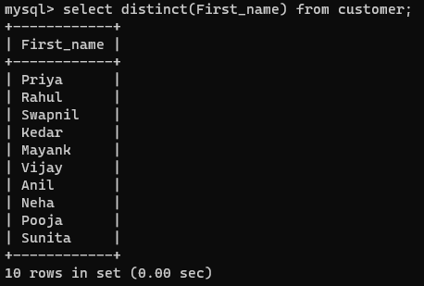

**Write a query to show first name and last name together with customer id and DOB.**

**Query:**

